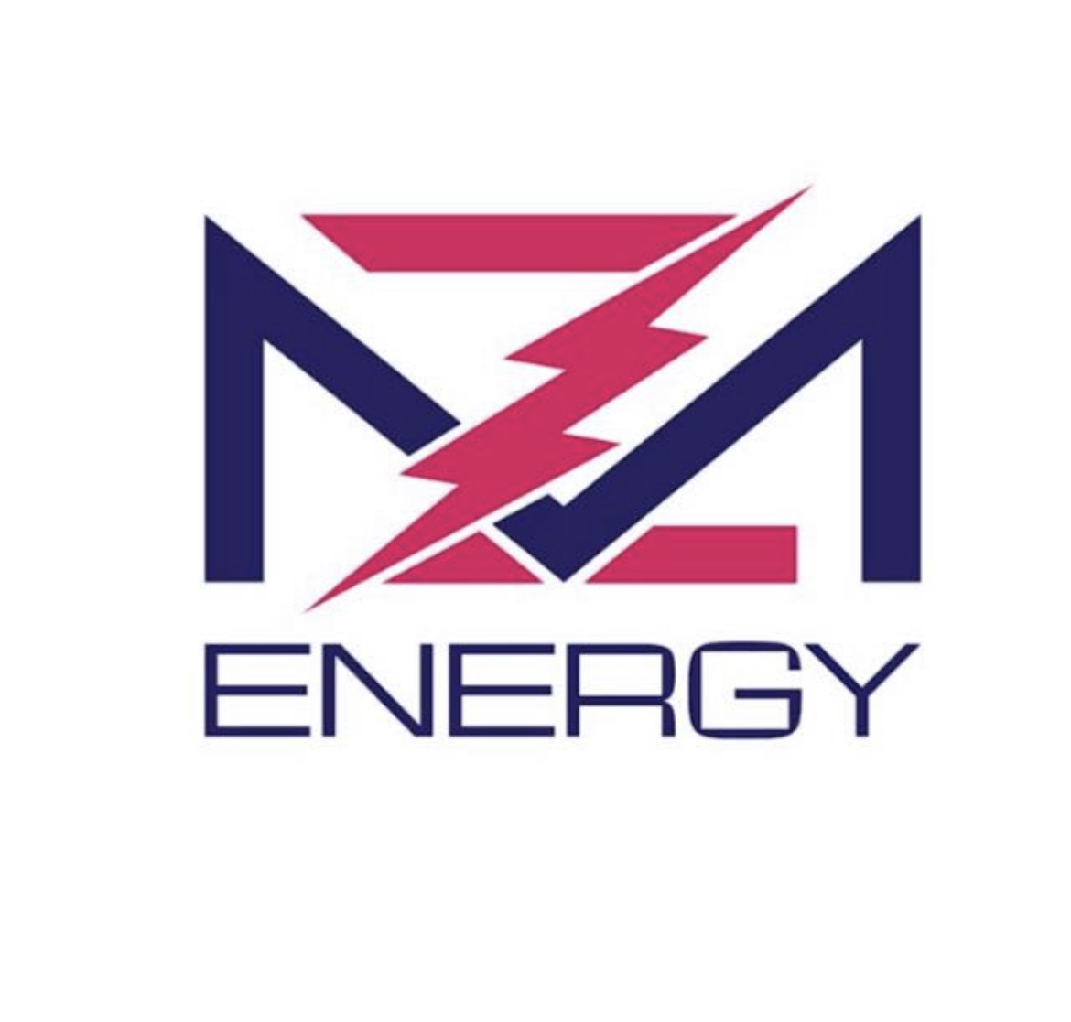
Letter of Representation (LOR)

This letter of representation is often required by electric retail suppliers to allow us to exclusively negotiate bids on your behalf as it is the industry standard to release quotes to only one entity. In this case, we are representing the best interest of your firm.

Signing the LOR commits the suppliers to MZ Energy but does not obligate you to execute an electric agreement.

When you enter into an energy contract facilitated by MZ Energy, this agreement is secure for the duration of your contract in order to fulfill our services to you. Our services are paid for by the energy/utility company.

On-Going Services we provide cover but are not limited to:
Energy Procurement Services.
Negotiations of terms and conditions that lead to a higher quality contract.
Customer Services associated with; adding and/or deleting meters.
Facilitation of new service
Continuous serve for lower electric rates using forward pricing.

If you choose not to enter an energy contract, either party may cancel.

MZ Energy LLC
Signature | Signature
Printed Name | Printed Name
Title | Title
Company | Date

